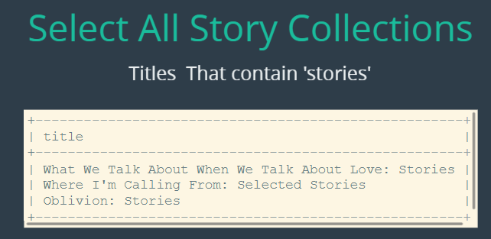

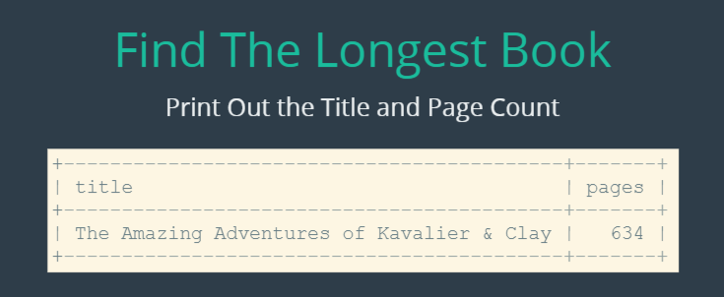

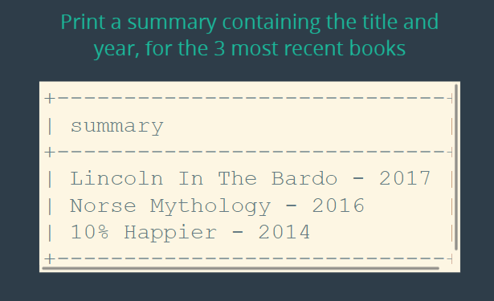

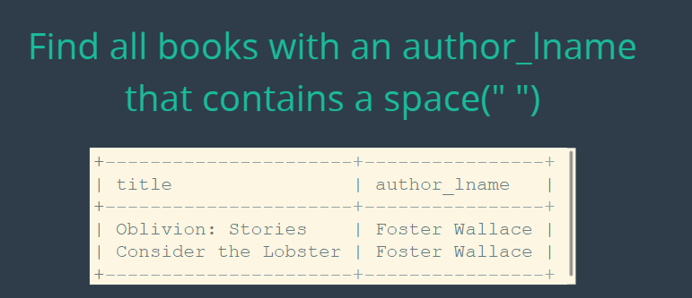

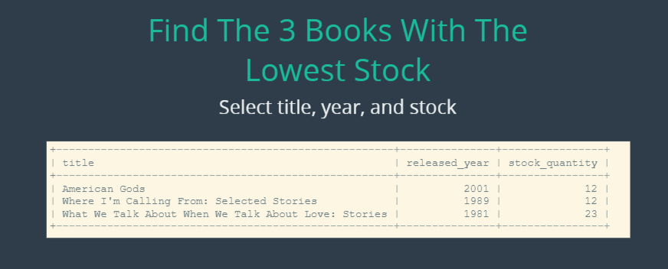

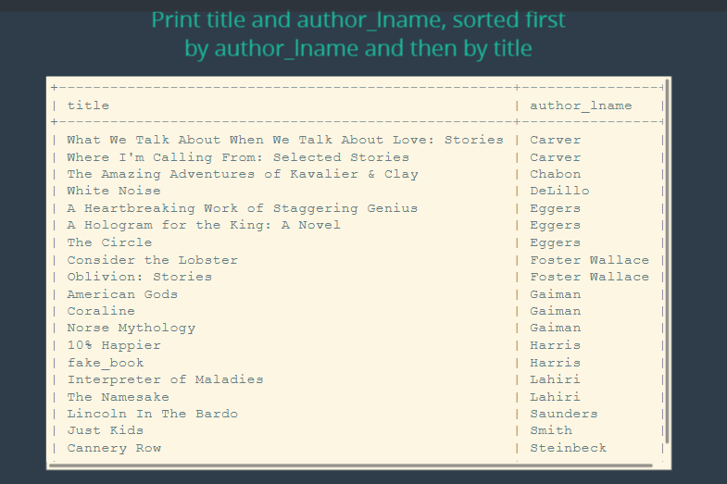

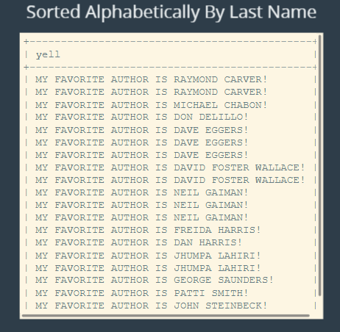

**The solutions:**

select title from books where title like '%stories%';

select title, pages from books order by pages desc limit 1;

select concat_ws('-', title, released_year) as summary from books order by released_year desc limit 3;

select title, author_lname from books where author_lname like '% %';

select title, released_year, stock_quantity from books order by stock_quantity limit 3;

select title, author_lname from books order by author_lname, title;

select upper(concat('My favorite author is ', author_fname, ' ', author_lname, ' ', '!')) as yell from books order by author_lname;